Mile Cross Primary School

This plan outlines our current provision, showing how we intend to increase the accessibility of our school for children, staff, parents/carers and visitors with disabilities.

Accessibility Action Plan
2022 – 2025
Stuart Allen
Headteacher

 | Page No.
- The purpose of this plan | 2
- What does accessibility and inclusion mean for our school? | 2
- Definition of disability | 3
- Information about our school | 3
- What we have in place to make our school accessible | 4
- Challenges to accessibility that we want to address | 4
- Action Plan | 5

- The Purpose of this Plan
We want all children to feel safe and secure, enjoy learning and access a wide range of opportunities and experiences that will shape the rest of their lives. We set high standards for all, encourage independence and celebrate achievement of all kinds. Through a broad and balanced curriculum, adapted and adjusted to need, we provide challenge and guidance to support all children who attend Mile Cross Primary School to grow into confident, capable young people, well prepared for life in the 21st century.

This plan sets out how our school will increase access to education for children with disabilities in three key areas:
- increasing the extent to which children with disabilities can participate in the school curriculum;
- improving the environment of the school to increase the extent to which children with disabilities can take advantage of education and associated services;
- focusing on how we deliver information, which is often only provided in writing to improve accessibility for all including parents with disabilities.

Our school accessibility plan will be reviewed every three years and reported on annually.

- What does accessibility and inclusion mean for our school?

We are committed to providing a school that can be accessed, understood and used to the greatest extent possible by all people regardless of their ability or disability.

When reviewing or redesigning our school environment (such as our buildings, technology, information, communication or culture) we will be guided by the following:

- Provide the same means of use to enable access for all users: identical whenever possible; equivalent when not

- Avoid segregating or stigmatizing any users

- Provisions for privacy, security and safety shall be equally available to all users

- Ensure dignity in use for all users.

- Definition of disability

The definition of disability is set out in the Equality Act 2010, Part 6:
‘A physical or mental impairment which has a substantial and long-term effect on a person’s ability to carry out normal day to day activities’.
Not all disabilities are visible and under this definition might include learning difficulties, including specific learning difficulties like dyslexia, social communication difficulties such as autistic spectrum disorder, complex speech and language difficulties and certain medical conditions.
Many of our disabled children with disabilities are also recorded as having special educational needs (SEN). Further information about our SEN provision can be found in our SEN Information Report.

Reasonable adjustments for disabled people

Where something the school does places a disabled person at a substantial disadvantage compared to a non-disabled person, we will take all reasonable steps to try to avoid that disadvantage. This may mean changing the way we work, providing extra equipment or removing physical or other barriers.

We will take steps to ensure equity of provision so far as this is possible.

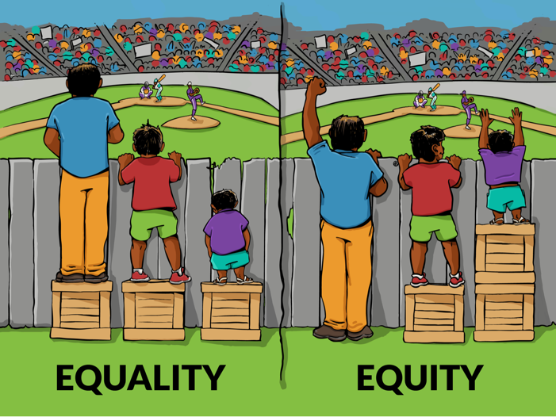

- Information about our school
You can find out about our school on our website here.

- What we have in place to make our school accessible

Physical Features | Flat level flooring throughout, lift between ground and first floors, evacuation chairs and emergency refuge points, accessible toilets on each floor, push taps, technology for hearing loops, contrast markings to support those with visual impairments, dedicated accessible parking spaces*
Teaching and learning strategies | Communication-friendly classrooms, Signalong (Early Years), targeted adult support, sensory breaks, interventions for curriculum subjects, emotional regulation and social development*
Procedures | Many disabled children have a PEEP (Personal Emergency Evacuation Plan) outlining actions to be taken in the event of an emergency.  Comprehensive risk assessments are conducted for trips and visits.
Resources | Reading pens, books with yellow pages, overlays, writing slopes, pencil grips, Brailling devices, tactile resources, iPad technology (e.g. Showbie) ear defenders, writing slopes, wobble cushions, toilet steps, visual timetables, now/next boards*
(*THESE LISTS ARE NOT EXHAUTIVE. PLEASE SEE SEN INFORMATION REPORT FOR FURTHER DETAILS.)

- Challenges to accessibility that we want to address

These are most particularly concerned with ensuring that children with a neurodiverse profile are supported to access all aspects of school more easily.

Action Plan

 | What we are doing | What will it mean for students | Who is responsible for achieving it | When it will be achieved
1 | Exploring the possibility of an accessible minibus. | Improved access to out of school trips for physically disabled wheelchair users | Deputy Head | July 2022
2 | Integrating body breaks with the school day and exploring Sensory Circuits. | Improved access to the taught curriculum for children with sensory and/or attentional difficulties | SENCO | July 2022
3 | Auditing books to ensure dyslexia-friendly texts are available in the library and classrooms. | Improved access to appropriate texts for children with reading difficulties | Reading Leads & SENCO | July 2022
4 | Implementing a wider range of accessibility and easy read features on the school website. | Improved access to information for parents, visitors and children with disabilities | SENCO | February 2023

